**JAVA CODES 2**

1.Find the biggest element in array

Code:

import java.util.*;

class BigInArray{

public static void main(String args[]){

Scanner obj = new Scanner(System.in);

int n= obj.nextInt();

int[] a=new int[n];

for(int i=0;i<n;i++){

a[i]=obj.nextInt();}

int b=a[0];

for(int i=0;i<n;i++){

if(a[i]>b){

b=a[i];}

}System.out.println("The largest element is:"+b);

}

}

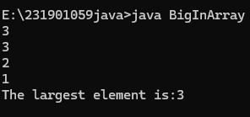

2. Find the sum of N elements

Code:

import java.util.*;

class SumOfN{

public static void main(String args[]){

Scanner obj=new Scanner(System.in);

int i=1,s=0;

int n=obj.nextInt();

while(i<n+1){

s=s+i;

i++;

}System.out.printf("The sum of first %d natural number is: %d",n,s);

}

}



3. Write a code using array which breaks the loop when the number is 5

Code:

public class BranchingStatements {

public static void main(String[] args) {

int[] numbers = {1, 2, 3, 4, 5, 6, 7, 8, 9, 10};

for (int num : numbers) {

if (num == 5) {

break; }

System.out.println(num);

}

}

}

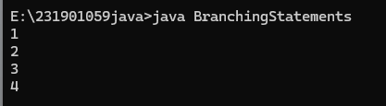

4.Find whether the given day is weekday or weekend.

import java.util.Scanner;  
class Loop  
{  
public static void main(String args[]){  
Scanner obj= new Scanner([System.in](http://System.in));  
String n=obj.nextLine();  
switch(n){  
case "Monday":  
case "Tuesday":  
case "Wednesday":  
case "Thursday":  
case "Friday":  
System.out.println(n+ "is a Weekday");  
break;  
case "Saturday":  
case "Sunday":  
System.out.println(n+ "is a Weekend");  
break;  
default:  
System.out.println("Invalid day");  
}  
}  
}

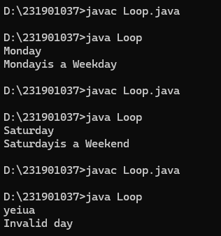

5. public class Loops {

public static void main(String[] args) {

String day = "MONDAY";

String typeOfDay = switch (day) {

case "MONDAY", "TUESDAY", "WEDNESDAY", "THURSDAY", "FRIDAY" -> "Weekday";

case "SATURDAY", "SUNDAY" -> "Weekend";

default -> "Invalid day";

};

System.out.println("Type of Day: " + typeOfDay);

}

}

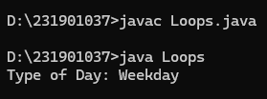

6: Perform basic arithmetic operations on two numbers.

class Sample

{

public static void main(String[ ] args)

{

int a = 10;

int b = 3;

System.out.println("a + b = " + (a + b) );

System.out.println("a - b = " + (a - b) );

System.out.println("a * b = " + (a * b) );

System.out.println("a / b = " + (a / b) );

System.out.println("a % b = " + (a % b) );

}

}

